The Complete Reuleaux Generating Arrangement
Foundational geometry and an introduction to the parent construction
Christopher David Peterson
Independent Researcher | July 2026

Abstract
The classical Reuleaux triangle is the intersection of three congruent disks whose centres form an equilateral triangle with side equal to the disk radius. This paper defines and studies a larger labelled object generated by the same data: the complete arrangement of the three supporting circles, their disks, centres, pairwise intersections, and incidence relations. The classical Reuleaux region is recovered exactly by disk intersection and is not redefined. The complete arrangement contains six distinct circle-pair intersections. Three are the generating centres; the remaining three form a second, oppositely oriented equilateral triangle of side 2s. The two triangles share a centroid and have circumradii in the exact ratio 2:1. Each Reuleaux boundary arc has a unique supporting-circle continuation, so the complete arrangement is a canonical completion of the exact arc data, although its retention remains a choice of mathematical object. We then distinguish the planar theorems from a three-dimensional extension: requiring a fourth point to be non-coplanar and one edge length from all three generating centres yields two mirror-related regular tetrahedra. This is an explicit construction principle, not a consequence forced by planar incidence alone. The results provide a rigorous geometric foundation and a controlled introduction to the wider parent-construction programme.
Keywords: Reuleaux triangle; circle arrangement; incidence geometry; equilateral triangles; tetrahedral extension; parent construction.

1. Introduction
A Reuleaux triangle of width s is formed from three disks of radius s centred at the vertices of an equilateral triangle of side s. The familiar boundary retains one arc from each generating circle and encloses a convex body of constant width. That classical definition is complete for the study of the region.
The present work asks a different question: what geometric structure is carried by the complete labelled generators before the result is restricted to the three-arc boundary? The answer is not another Reuleaux triangle. It is a parent construction from which the classical region is extracted.
complete labelled generator ⟶ selected disk intersection
This distinction matters logically. The full circles can be reconstructed uniquely from exact non-degenerate boundary arcs, but they are not conventionally included as parts of the Reuleaux region. Retaining them therefore makes additional global incidences explicit without claiming that the classical definition discarded or destroyed unrecoverable information.
The paper has four aims: to define the parent arrangement precisely; to derive its six-point incidence geometry; to establish its exact dual-triangle and 2:1 radial structure; and to identify the additional rule required for a regular tetrahedral extension. Later URF proposals involving helical continuation, closure, spectral modes, or physical interpretation are not derived here.
Epistemic convention. Definitions fix the objects under study. Theorems and corollaries follow from those definitions. Construction principles introduce additional rules. Physical interpretations are hypotheses and are not promoted to geometric consequences.

2. Euclidean setup and the parent object
Let s > 0 and choose Cartesian coordinates
A=(0,0), B=(s,0), C=(s/2, √3s/2).
The points A, B, and C form an equilateral triangle of side s. For X ∈ {A,B,C}, define
Γ_X={p∈ℝ²: ‖p−X‖=s}, D_X={p∈ℝ²: ‖p−X‖≤s}.
Definition 2.1 (Complete Reuleaux Generating Arrangement). The parent arrangement G_s is the labelled incidence structure consisting of the centres A, B, C; the circles Γ_A, Γ_B, Γ_C; the closed disks D_A, D_B, D_C; and their intersection and containment relations.
Definition 2.2 (Classical extraction). The classical Reuleaux region associated with G_s is R_s=D_A∩D_B∩D_C.
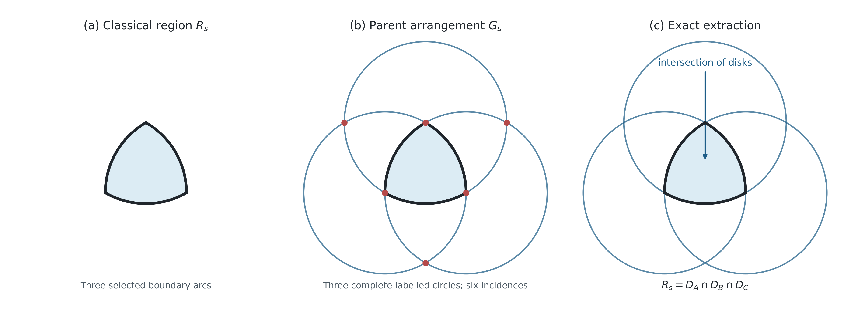
Figure 1. Region, parent, and extraction. The complete arrangement does not replace the classical Reuleaux triangle; it contains the labelled generating data from which the region R_s is recovered exactly.

3. Canonical completion of the boundary arcs
Proposition 3.1 (Unique supporting-circle continuation). Each non-degenerate circular boundary arc of R_s has a unique continuation to one of the complete circles Γ_A, Γ_B, Γ_C.
Proof. Any three non-collinear points on a circular arc determine a unique circle. Equivalently, the non-zero constant curvature determines a radius and centre. Extending the arc along that circle introduces no continuous geometric parameter. ∎
The proposition establishes canonical reconstructibility, not conventional membership. The full supporting circle is uniquely encoded by the exact arc, but the classical object remains the disk intersection. G_s is therefore best described as a canonical parent arrangement associated with R_s.

4. Six-point incidence geometry
Each pair of circles has equal radius s and centre separation s. Hence every circle pair intersects in two points. One point is the remaining generating centre. For example, Γ_A∩Γ_B contains C and its reflection across line AB.
C′=(s/2, −√3s/2).
Cyclic calculation gives the other two external intersections
A′=(3s/2, √3s/2), B′=(−s/2, √3s/2).
Theorem 4.1 (Six distinct intersections). The three labelled circle pairs have exactly six distinct intersection points: A, B, C, A′, B′, and C′.
Proof. There are three unordered circle pairs, each with two intersections because 0<s<2s. The listed coordinate solutions are pairwise distinct. ∎
Theorem 4.2 (External equilateral triangle). The external points A′, B′, C′ form an equilateral triangle of side 2s with orientation opposite to ABC.
Proof. Direct subtraction gives ‖A′−B′‖=‖B′−C′‖=‖C′−A′‖=2s. The signed areas of the ordered triples ABC and A′B′C′ have opposite signs. ∎
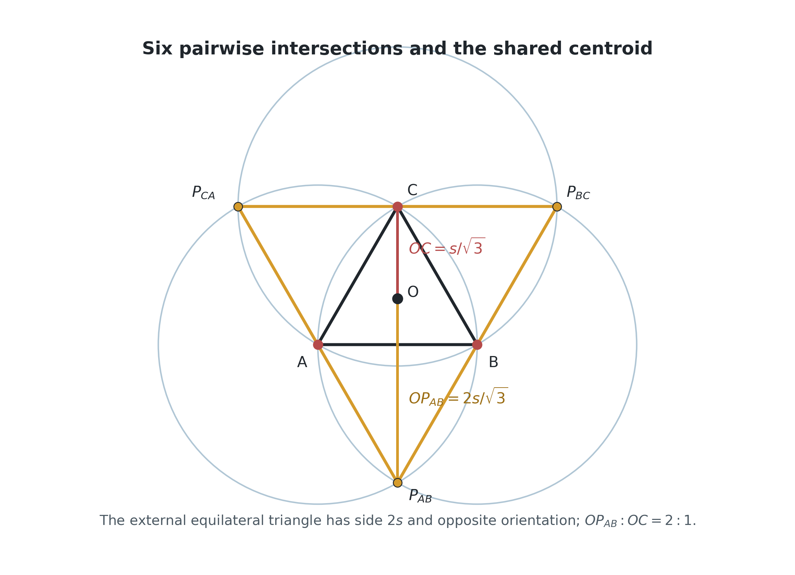
Figure 2. The six circle-pair intersections. The inner and external equilateral triangles share centroid O. Their circumradii are s/√3 and 2s/√3.

5. Centroid, scale ratio, and symmetry
Both equilateral triangles have centroid
O=(s/2, √3s/6).
The distances from O to a generating centre and to an external intersection are
R_inner=s/√3, R_outer=2s/√3.
Corollary 5.1 (Exact radial ratio). The two circumradii satisfy R_outer/R_inner=2.
This ratio is a consequence of the circle-intersection coordinates. It requires no physical interpretation. The arrangement is invariant under the dihedral symmetries of the equilateral triangle when labels are transformed with their circles. The six points form two three-point orbits under 120° rotation about O.
The phrase ‘hexagram’ may be used descriptively for the superposed inner and outer triangles, but it should not obscure the incidence origin of the six points: they arise as labelled circle-pair intersections, not by independently inscribing a star polygon.

6. What follows—and what does not—from the plane
The planar construction establishes complete circles, six intersections, two oppositely oriented equilateral triangles, a shared centroid, and the 2:1 circumradius ratio. It does not select a point outside the plane. Infinitely many three-dimensional embeddings preserve the planar data, and the signs ‘above’ and ‘below’ are not distinguished without an orientation convention.
Scope result. No regular tetrahedron is forced by G_s alone. A tetrahedron becomes exact only after an additional distance and non-coplanarity requirement is introduced.

7. Conditional tetrahedral extension
Construction Principle 7.1 (Equidistant non-planar extension). Introduce D∉aff{A,B,C} subject to ‖D−A‖=‖D−B‖=‖D−C‖=s.
Any point equidistant from A, B, and C lies on the line perpendicular to their plane through O. Writing D=(s/2, √3s/6, h), the condition ‖D−A‖=s gives
s²/3+h²=s², hence h=±s√(2/3).
Theorem 7.2 (Two tetrahedral solutions). Construction Principle 7.1 has exactly two solutions D_±=(s/2, √3s/6, ±s√(2/3)). Each gives a regular tetrahedron ABCD_± of edge s.
Proof. The equidistance locus is the centroidal normal line. The distance equation has exactly the two stated non-zero solutions. Since AB=BC=CA=s by construction and D_± is distance s from A, B, and C, all six edges are equal. ∎
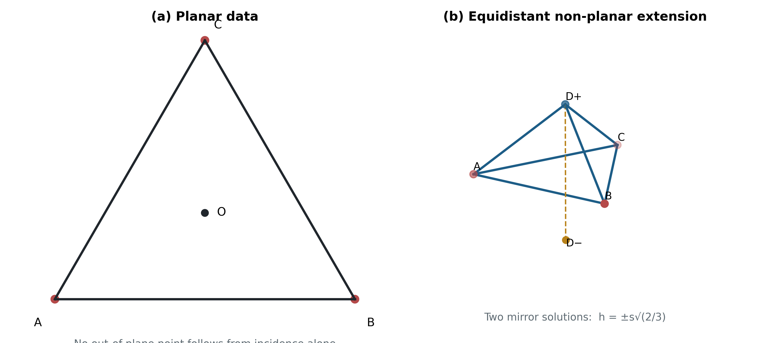
Figure 3. Conditional lift. Panel (a) contains only the planar parent data. Panel (b) applies the equidistant non-planar extension and obtains two mirror-related regular tetrahedra. Choosing D+ rather than D− requires an orientation convention or further rule.

8. The parent-construction programme
The results above define the starting object for a larger programme. Once a regular tetrahedron has been selected, congruent tetrahedra can be attached face to face. A consistent handed attachment rule produces a Boerdijk-Coxeter helix. That continuation is standard tetrahedral geometry, but its connection to G_s passes through Construction Principle 7.1.
G_s ⟹ six-point planar geometry —[extension principle]→ tetrahedron → face-sharing helix
The distinction between the double arrow and the labelled construction arrow is substantive. The first transition is deductive within the defined parent arrangement. The second introduces new information. A subsequent paper can ask whether the parent contains an invariant capable of selecting extension, orientation, or handedness; this paper does not assume that such a selector has already been proved.

9. Claim-status summary
Statement | Status
Complete generating arrangement | Definition
Classical region recovered by disk intersection | Definition / exact extraction
Arc-to-circle completion | Proven unique
Six distinct intersections | Theorem
External equilateral triangle, side 2s | Theorem
Shared centroid and 2:1 ratio | Corollary
Non-planar equidistant fourth point | Construction principle
Regular tetrahedron under that principle | Theorem
Choice of upper/lower orientation | Additional convention
Physical substrate or mechanism | Open hypothesis

10. Discussion
The contribution is an enlargement of the object of study, not a correction to the Reuleaux triangle. The complete labelled arrangement is natural because its circles are uniquely recoverable from the boundary arcs and because it exposes a global incidence structure absent from the three-arc presentation. The resulting six-point geometry and 2:1 ratio are exact.
Equally important is the boundary of the result. Canonical circle completion does not entail a physical substrate, and planar incidence does not force three-dimensional lift. Stating the tetrahedral step as a construction principle preserves its mathematical value while making its evidential burden visible. This separation is necessary before claims about helices, closure, spectra, or natural systems can be assessed.

11. Conclusion
The Complete Reuleaux Generating Arrangement G_s is a well-defined parent construction associated with the classical Reuleaux triangle. Its three labelled generating circles produce six distinct pairwise intersections. These divide into two oppositely oriented equilateral triangles with a common centroid and circumradii in the exact ratio 2:1. The supporting-circle completion is unique, while retention of the complete arrangement defines the expanded object under study.
A regular tetrahedron follows exactly if an equidistant non-planar fourth point is introduced. The extension has two mirror solutions and is conditional rather than forced by the plane. The foundational result can therefore be stated compactly:
canonical parent arrangement ⟹ exact planar incidence geometry;
equidistant non-planar extension ⟹ regular tetrahedron.
This establishes a defensible first layer for URF and frames the next mathematical question: whether the parent arrangement supplies, or must be supplemented by, a rule selecting tetrahedral propagation and its handed continuation.

References
Bonnesen, T. and Fenchel, W. Theory of Convex Bodies. BCS Associates, 1987.
Coxeter, H. S. M. Regular Polytopes, 3rd ed. Dover Publications, 1973.
Gardner, M. “The Reuleaux Triangle and Its Curious Properties.” Mathematical games literature; classical expository discussion of constant-width geometry.
Reuleaux, F. The Kinematics of Machinery. Macmillan, 1876.

